Author Guide for 7.5 x 9.25 Standard

Subtitle style for Author Names in a multi-authored chapter, etc.

Congratulations on signing with Apress. The purpose of this document is to help you with the different processes at Apress.

As you can see, we are using a Word template with styles–identical to the one you'll be using to write your book–to deliver these instructions. This way, you can familiarize yourself with our house styles and use the examples in this document to properly format each chapter as you write. Toolbars have been locked, so for things like **Bold** or Italics, please use the styles **Strong** and Emphasis in the style menu. And for **Bold** with Italics, Intense Emphasis.

Examples of these styles can be seen in the first paragraph styled Body Text First and the following paragragh styled simply as Body Text.

Your focus should be on the writing rather than formatting. So, while these styles are here to help you shape your text, be aware that Apress will validate each chapter for style consistency and typeset it later in the development process.

You may see a Security Warning when you initially open the template, as shown in the image below:

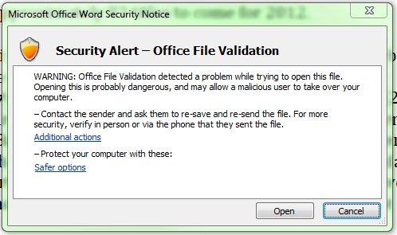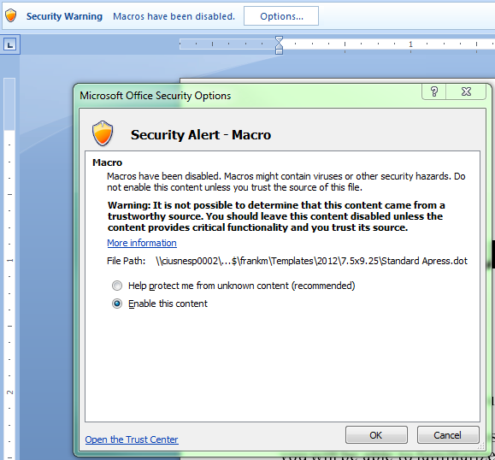

It is perfectly fine to click on the Options button and Enable this content. These documents were created by Apress and do not have any security issues.

n **Note** We will have more on the template in the [Template section](#_Word_Template).

In the following pages we will describe:

* Your Team and Resources
* SharePoint
* Template Use
* Artwork

By following these instructions, your first draft will be formatted properly and will help to make writing the rest of your book an enjoyable experience.

# Your Team and Resources

Your team will consist of an Acquisitions Editor (the editor who helped sign you to a contract), a Coordinating Editor (the person who will manage your project's development and serve as your primary contact), a Technical Reviewer (hired by Apress to ensure your title is technically accurate), and a Developmental Editor (an editor who will help shape your content; sometimes the Acquisitions Editor also serves as the Developmental Editor).

n **Note** Apress Marketing, Sales, Production, and Accounting departments will also be working on your behalf during the title's development. You can get accounting and royalties information at [authorservices@apress.com](mailto:authorservices@apress.com).

# SharePoint

SharePoint is an online content management system that enables authors, editors, technical reviewers, and other authorized users to collaborate on projects in real-time. SharePoint works best with Internet Explorer. For Mac users, FireFox or Chrome might be the best browser option.

SharePoint was created to give authors and Apress a view into all chapter and title information at any time. The system's permissions are assigned on an as-needed basis so that access is restricted to authorized users.

Your Acquisitions Editor will provide you with username and password to access SharePoint. Apress SharePoint project sites can be found at [publish.apress.com](https://publish.apress.com/). You begin at the SharePoint home page. Once logged in, you will see fields on the right-hand side for you to change your password. Please do so before reviewing any materials.

A list of assigned titles should appear as links. If you only have one title with Apress, you should see only one title:

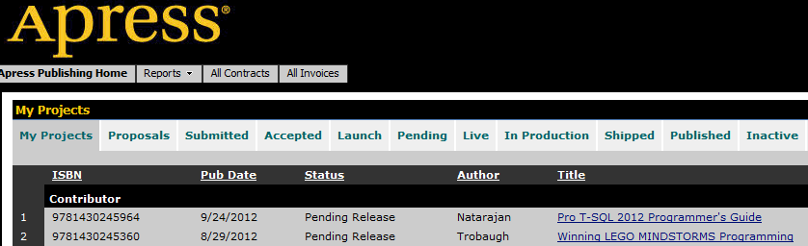

The following will be listed for each title:

* ISBN (identification number)
* Publication date
* Title status
* Author (lead author's last name)
* Title (linked to the project page)
* Data (link to view and edit title information)

You can access the links to the project and data pages on a regular basis. See below for some detail.

## Project Page

Clicking on a title from your home page will bring you to that project. You'll be uploading your chapter and artwork submissions to this area. Currently, Tasks at the top of the page are not being utilized through the system. For now, you will be given tasks by your Coordinating Editor via email/phone. Manuscripts resides just below the Tasks section. All current versions of the chapters can be seen. Clicking on Manuscripts (near the top or on the left sidebar) will expand the Manuscripts view.

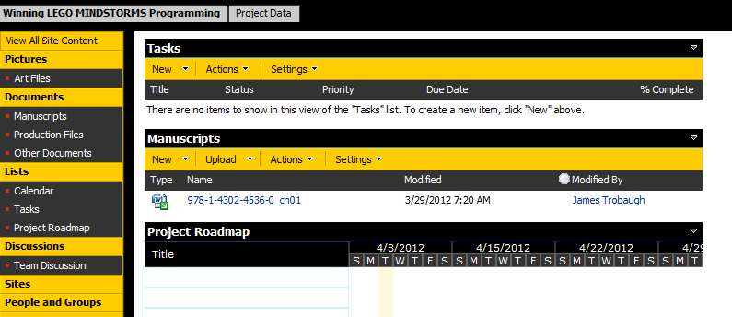

The left sidebar consists of a number of menu items. Here are the important ones:

**Pictures**

* Art Files

**Documents**

* Manuscripts
* Production Files
* Other Documents

### Tasks

This **section** will be used more frequently by Coordinating Editors when assigning work to Technical Reviewers and Copyeditors. In the future, there may be tasks assigned to you. When you are assigned a task, SharePoint will automatically send you an email and your task should appear under the Tasks heading:

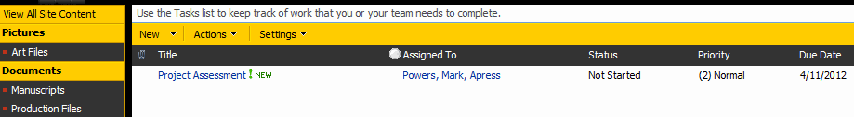

### Art Files

Art Files contain numerous folders, however, all your artwork should be zipped and uploaded to Author Submission. If updated artwork needs to be re-submitted, the Coordinating Editor should be notified and zip files uploaded to Author Submission. See [Art Section](#_Artwork) for more detail.

### Manuscripts

This location is the central repository you'll be uploading and downloading chapter content. Chapter numbers should be entered as 01, 02, 03, etc. When naming a chapter, please follow our naming convention: ISBN\_ChapterNumber. For example, Chapter 3 would be 978-1-4302-5555-5\_Ch03. If your book project features more than one author, include your surname in the file name (i.e., 978-1-4302-5555-5\_Ch03\_Smith).

n **Note** Appendices are treated like chapters, and therefore should be assigned a chapter number in the Properties dialogue box during the upload process. The numbering can follow consecutively after the last chapter.

In Manuscripts, you will see:

* Chapter Number
* Type (icon shows file format and if a file is checked out)
* Name (shows filename)
* Modified (stamp from the last time a file has been modified)
* Modified By (user's name that last modified the file)
* Status

In Manuscripts, you can track each chapter's version history, in addition to its current status. The status reflects the completion of that step in our process. So, for instance, Initial Write means that you have uploaded the first version of the chapter.

n **Note** If you have a Part or Front Matter element (anything other than a chapter or appendix) be sure to mark a capital X in the Properties dialogue box during the upload process, rather than adding it to the filename.

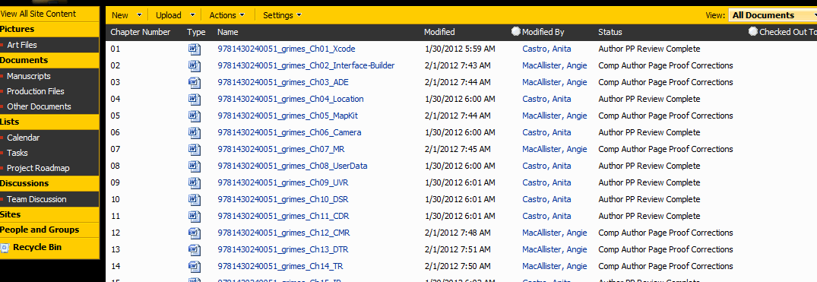

Likewise, the status of Author Review Complete means that you have uploaded the chapter after reviewing and implementing the editor's and technical reviewer's feedback. The chapter can have any of the following statuses:

* Initial Write: First draft of your chapter.
  + Author assigns status.
* First Draft Complete: Editorially accepted.
  + Editor assigns status.
* TR Complete: Technically reviewed.
  + Technical Reviewer assigns status.
* Book Editor Review Complete: Developmental Editor has reviewed the chapter.
  + Editor assigns status.
* Author Review Complete: Author's review of Technical Reviewer's and DE's comments; essentially, this is your second draft.
  + Author assigns status.
* Editorial Signoff Given: All changes/comments have been addressed by the author and editor; the chapter is ready for copyedit.
  + Editor assigns status.
* Copyedit Complete: The chapter has been copyedited (and may contain copyeditor’s questions, in addition to suggested changes and comments).
  + Copyeditor assigns status.
* Copyedit Signoff: Author has resolved all edits, and cleared the document of all comments save for those intended specifically for Prodution. At this point, text is considered final.
  + Developmental Editor assigns status.
* Index Complete: Indexed. See [Production](#_Production_Files).
  + Vendor assigns status.
* Ready for Page Proof: Composition begins.
  + Vendor assigns status.
* Page Proof Complete: Page proofs in pdf format are ready for your review.
  + Vendor assigns status.
* Author PP Review Complete: Author has reviewed pdf page proofs, noting any minor text mistakes; comments/changes have been marked on the pdfs.
  + Author assigns status.
* Comp-Author Page Proof Corrections: Changes have been inserted into the pdfs.
  + Vendor assigns status.
* Production Review Complete: Coordinating Editor reviews the final pdfs.
  + Coordinating Editor assigns status.
* Final Manuscript Complete: All changes have been installed correctly.
  + Vendor assigns status.
* Index Copyedit Complete: Index has been copyedited.
  + Vendor assigns status.
* Final Index: Index has been formatted and added to the page proofs.
  + Vendor assigns status.

#### Check In

1. Click on Upload and select Upload Document

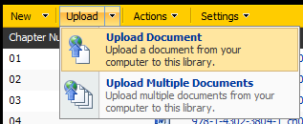

1. Browse for the filename, insert a comment (if necessary) and click OK

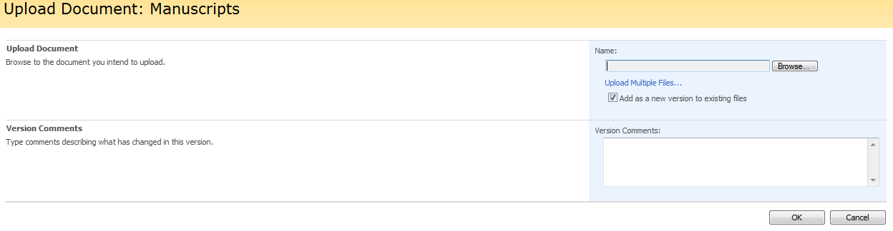

1. Update metadata: insert the correct Title, select Status, enter Chapter Number where the actual chapter number is placed or "X" for front matter then Check In.

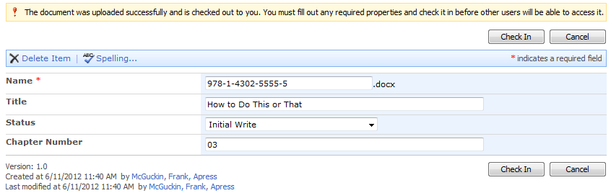

1. Find you new chapter listed with !NEW stamp.

C:\Users\frankm\Pictures\Upload4.png

#### Updating a Status

Did you check in the document without updating the status? Or forget something else? That is easy to fix.

1. Rollover the chapter title, click on the arrow in the right-hand corner, and select Edit Properties

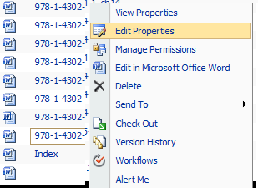

1. You will be prompted to Check Out the document. Click OK

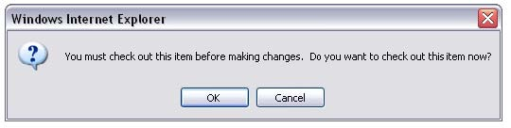

1. From this screen you can rename the file without affecting the version history, rename the title of the chapter within the system, adjust the chapter number, and change the status via a pulldown menu; the surname can also be added to the Name\* field

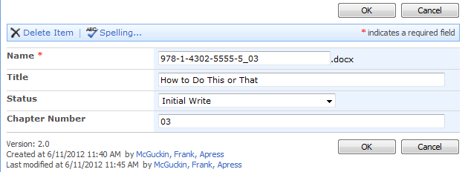

1. Do not leave checked out afterward (so that remains at "No"), add a comment (if necessary), and click OK

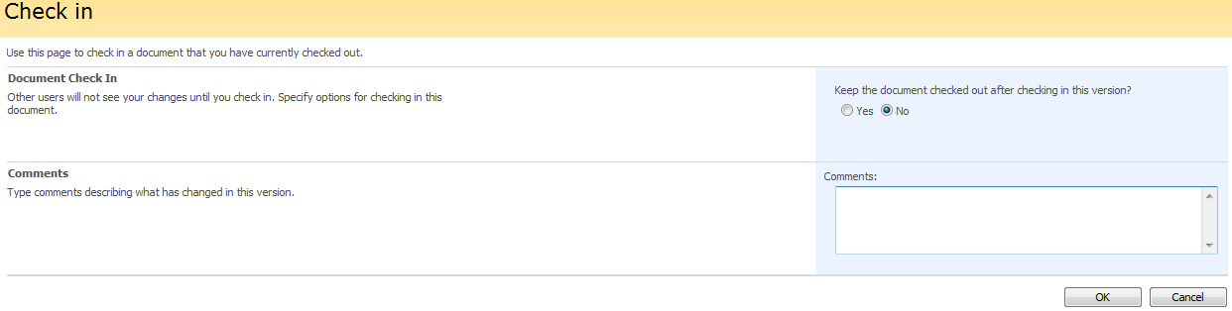

#### Version History

It is important when uploading a previous chapter to use the same naming convention consistently. This also extends to file type. If your previous version was .doc and now you have a .docx, the system will create a whole new version history. While we prefer to use the most update software like Word docx files, we understand older file types may still be floating around.

Checking previous versions of a chapter can be obtained by following these steps:

1. To view the version history of a chapter, rollover the chapter title, click on the arrow in the right-hand corner, and select Version History

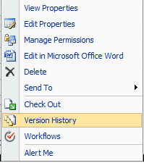

1. You will view each status, comment, and versions, along with a time stamp

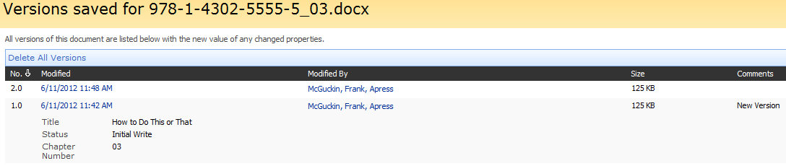

1. You can view the version history. Please contact the Coordinating Editor if a version needs to be restored or removed

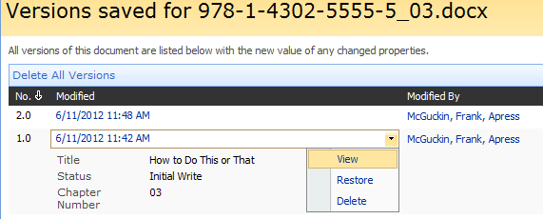

#### Check Out

When you click on a chapter in Manuscripts, you will be prompted to check out and edit the document. SharePoint will automatically save a copy to a local folder on your computer unless you save the chapter elsewhere.

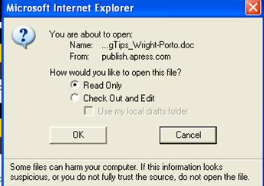

n **Caution** Do not alter the file names from their original filenames; SharePoint automatically saves a version of every file. Changing filenames will disrupt this feature and create a new line of file versions.

When you've completed your edit, save the file and close it. At this point you'll be asked if you wish to check the file back in. Select the correct status from the pulldown menu. Click Check In and it will now be the latest version of the chapter. Now you will be listed under the Modified By column in Manuscripts.

### Production Files

Page proofs, covers, and all other production-related files are kept in this area. The Coordinating Editor will contact you when it's time to access your page proofs. After review, upload the page proof pdfs back to the same location. See Reviewing Page Proofs. The Coordinating Editor will also describe the process for cover review when it is ready.

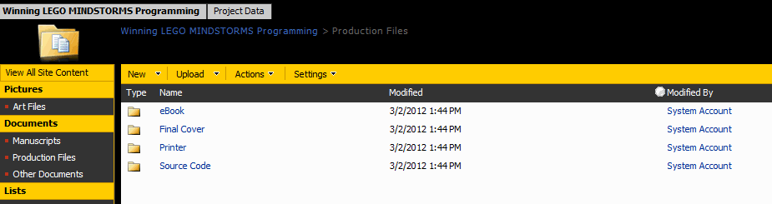

#### Source Code

Another feature is Source Code (any supplementary materials intended for readers’ use). Click this folder and use the Upload button. Files should be organized per chapter, and then all folders should be zipped together into one file. We prefer you follow the filename convention, 9781430255555.zip as an example. Your Coordinating Editor will review the filenames and folder structure before making them available to readers on [apress.com](http://www.apress.com).

#### Reviewing Page Proofs

Your Coordinating Editor will alert you when page proofs are available. Download the pdf files, insert notes, make edits, and address text changes in the pdf files using the Adobe Acrobat tools. [Adobe Reader](http://get.adobe.com/reader/) is a free download available online. The pdfs should have been made Commentable for Acrobat Reader. Notify your Coordinating Editor if there is an issue commenting.

This is your final opportunity to check images or code, and spot any lingering errors in the chapter. Ideally all significant changes should have been addressed before this stage.

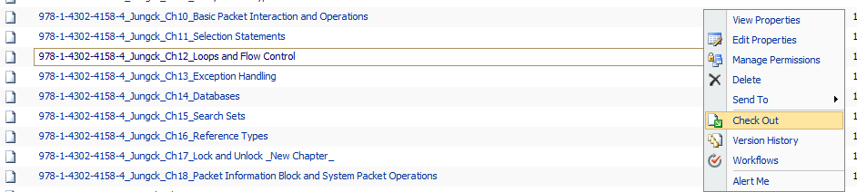

Check the pdfs out of SharePoint

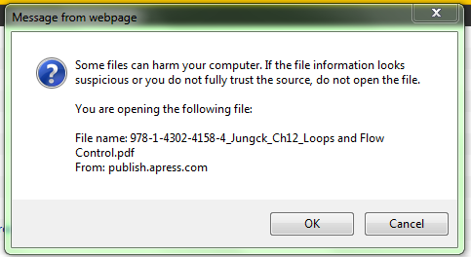

You may get a warning that you can click "Ok"

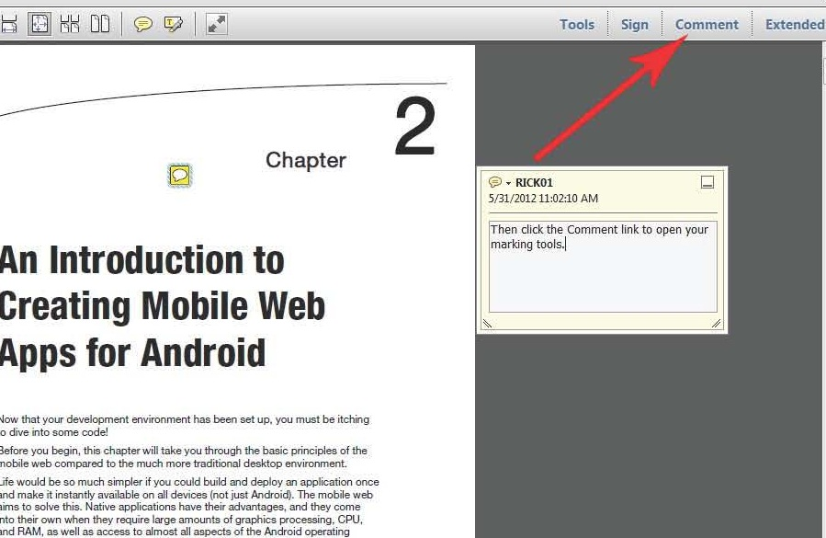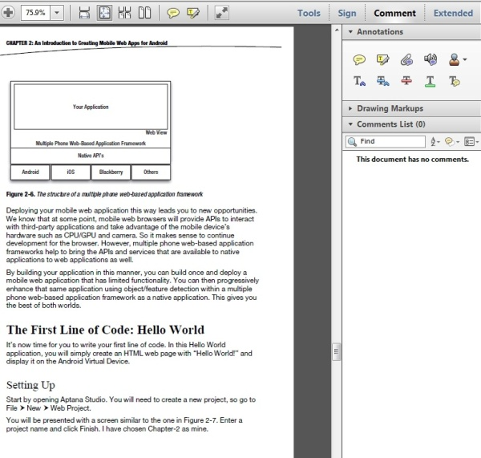

Click the "Comment" button to open the toolbar

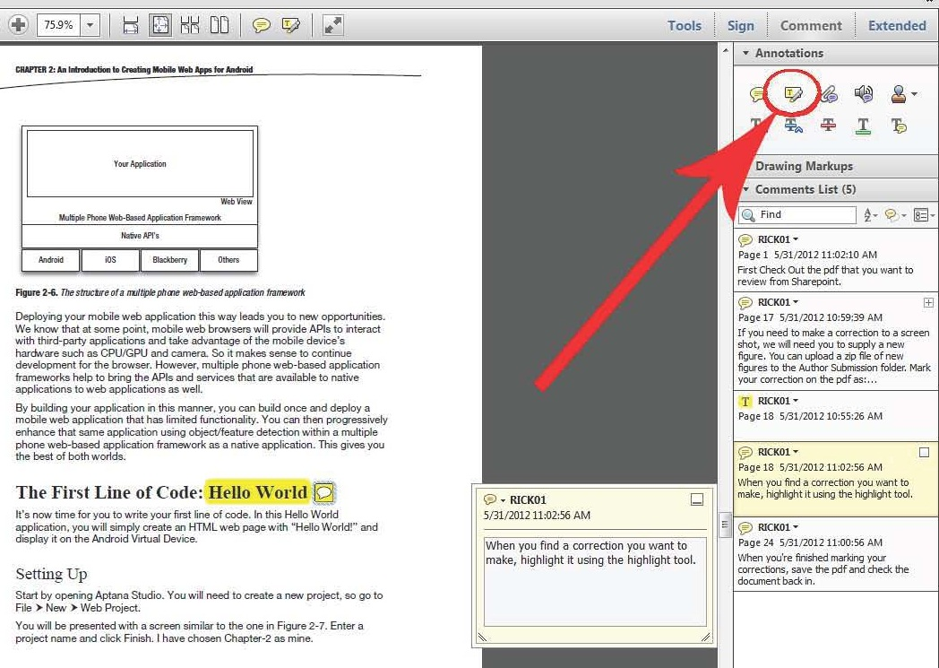

Highlight the correction needed

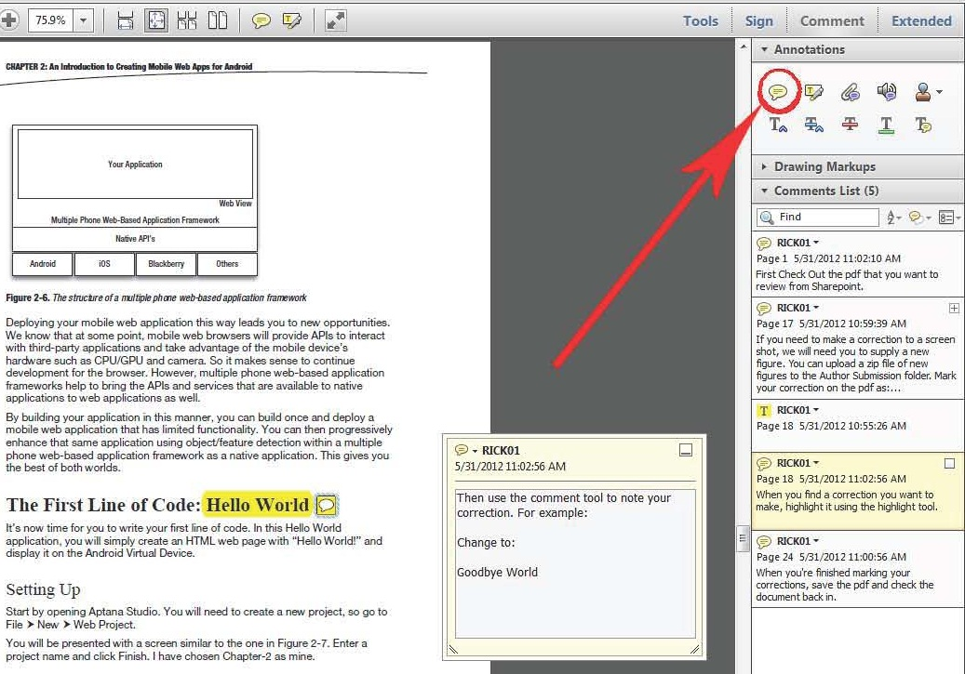

Click the comment tool to note your correction

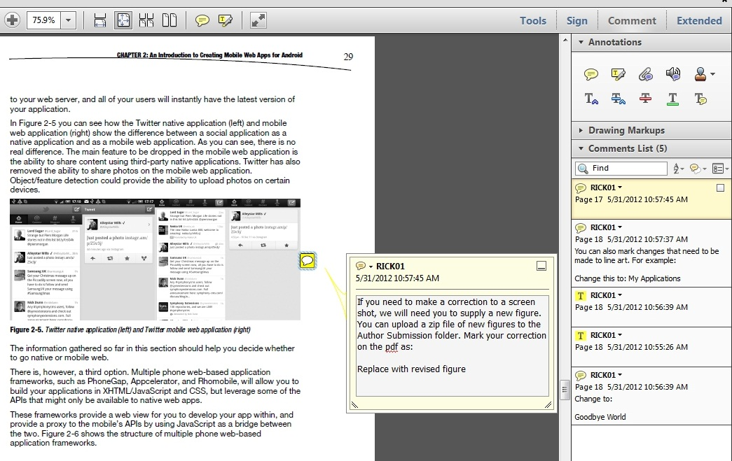

For changes to artwork, be sure to supply a new figure to the Author Submission folder

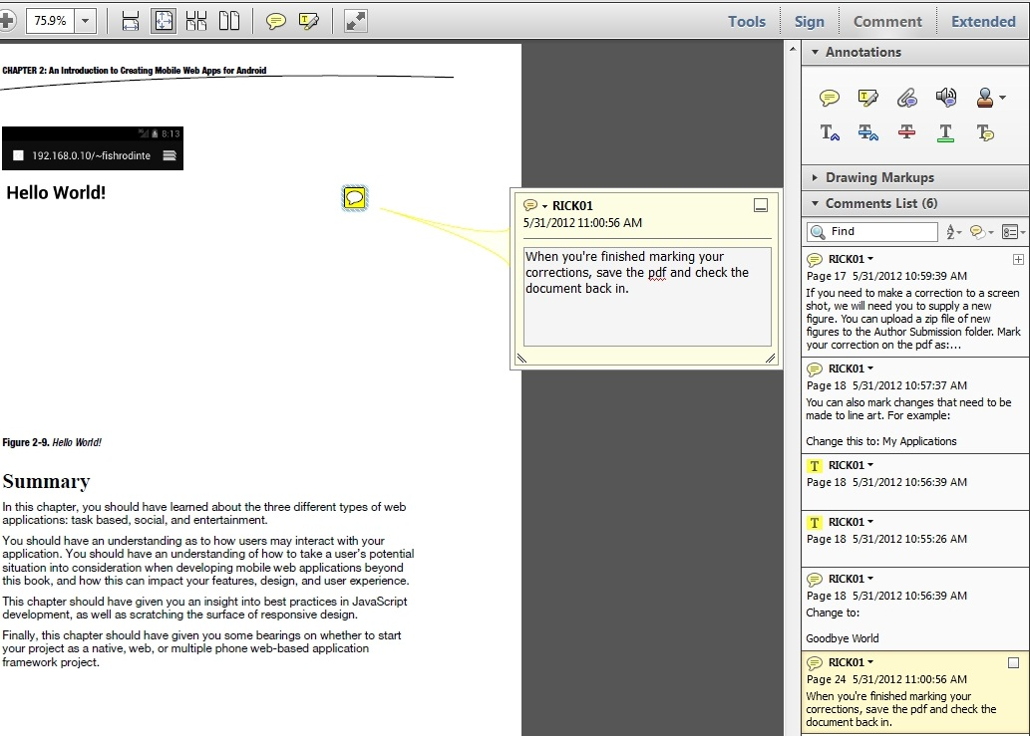

Once finished reviewing the pdfs, upload them back to SharePoint

Do not change the filenames; SharePoint automatically creates a new version upon upload, to maintain version integrity. Then go into the Manuscripts area and change the status of each Word chapter to Author PP Review Complete.

## Project Data

Title information disseminated to vendors, our own site, and the world comes from this area of SharePoint. Obviously, not all this information is released outward. It includes but is not limited to:

* ISBN and Title
* Author information
* Book descriptions
* Publication date
* Marketing information
* Table of Contents

You can view this information at any time during the process and alert your Coordinating Editor about any necessary changes, especially in regard to the book description or Table of Contents. (The Table of Contents will be sent to [apress.com](http://www.apress.com/) and other websites from this section on a regular basis through final publication. The final Table of Contents will be taken from the book.) You will have access to this information throughout the development process, so make sure any changes to your working table of contents are reflected in SharePoint.

# Word Template

The template's built-in styles help provide structure to your content. We will validate the styles during the development process in order to ensure consistency and prepare for the final XML conversion.

You can either write directly into the blank dot file or attach the dot file to a Word document to import the styles that you will need. If your book is already written, you can copy/paste your content into the blank Word dot and adjust the styles accordingly.

## Attaching a Dot File to a Word Doc

1. Open the Word document
2. Click on the Office button 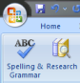
3. Click on the Word Options button C:\Users\frankm\Desktop\WordOptions.png
4. Click on Add-Ins (on the left-hand side)
5. Click the menu pulldown: Manage field
6. Select Templates from the drop down menu and click on Go
7. Browse for this dot template and make sure the checkbox for “automatically update document styles” is selected. Press OK

The dot file should now be attached to your Word document and you should be able to apply the correct styles. Examples of these styles in action can be seen throughout this document.

For those using Windows 7 and/or Word 2010, here are the steps:

1. Locate the file Standard.dot
2. Open the file in Word and Save As "Macro-enabled Template".

n **Note** Macro enabled is not a regular template. The file extension will be .dotm, not .dotx

1. Go to C:\Users\<UserName>\AppData\Roaming\Microsoft\Templates. Copy the .dotm file created earlier to this location. This location may not be visible in explorer. So use Start ä Run and paste the location there.
2. Open Word 2010, File ä New ä Choose "My Templates". Your new template will be visible.

n **Note** Every paragraph following a heading uses the Body Text First style. In all other paragraphs, you should use Body Text Cont. style.

The style sheet was created by Apress. In Word 2010, you can view the styles simply by clicking on the Home tab in the top ribbon and then clicking on Styles section. Styles have been locked into the style palette in order to preserve consistency. If you need a new style or find a problem, please contact your Coordinating Editor so that we may resolve it.

n **Tip** If you click AA Change Styles (toward the top-right corner of this document) and click the small button on the bottom right of the Styles section you will open the palette. You can rollover the palette to see what the specs are for existing styles or click Show Preview to see it in action.

All of the styles should be presented in the list that follows. You can drop existing text into the template, but it will may spawn new styles or default to Normal. You can go back and apply the necessary styles. As mentioned, we will have all the chapters validated and set for consistency.

## List of Styles

* Body Text First (for the first paragraph following a heading)
* Body Text Cont.
* Bullet
* Bullet Sub List
* Chapter Number
* Chapter Title
* Code First (adds space above)
* Code (blocks of code or standout lines of code that are not within a paragraph)
* Code Bold (character style within code)
* Code Caption
* Code Inline (code within a paragraph, such as methods, objects, or URLs)
* Code Last (adds space below)
* Dingbat Black (shows in the style menu as black for most symbols)
* Dingbat Gray (shows in the style menu as gray for NoteTipCaution)
* Emphasis
* Exercise Code
* Exercise Body
* Exercise Bullet
* Exercise Head
* Exercise Last
* Exercise Num (with indent)
* Exercise Num List (without indent)
* Exercise Subhead
* Figure
* Figure Caption
* Footer
* Footer Text
* Footnote
* Header (for the Running Head)
* Heading 1
* Heading 2
* Heading 3
* Heading 4
* Heading 5
* Intense Emphasis
* Note/Tip/Caution
* Numbered List
* Numbered Sub List
* Page Number
* Quote
* Quote Source
* Results
* SB Code
* Side Bar Body
* Side Bar Bullet
* Side Bar Head
* Side Bar Last
* Side Bar Num
* Side Bar Subhead
* Strong
* Table Caption
* Table Footnote
* Table Head
* Table Text
* Unnumbered List

## Examples of Styles

The following text will show you some examples of the styles that you will be using most as you write your chapter.

# Heading 1

Body Text First. THIS IS CODE INLINE This is dummy text that is being repeated. This is dummy text that is being repeated. This is dummy text that is being repeated. This is dummy text that is being repeated.

This is a bulleted list:

* Bullet. This is dummy text that is being repeated. This is dummy text that is being repeated. This is dummy text that is being repeated. This is dummy text that is being repeated.

Bullet Sub List. This is dummy text that is being repeated. This is dummy text that is being repeated. This is dummy text that is being repeated. This is dummy text that is being repeated.

Bullet Sub List. This is dummy text that is being repeated. This is dummy text that is being repeated. This is dummy text that is being repeated. This is dummy text that is being repeated.

* Bullet. This is dummy text that is being repeated. This is dummy text that is being repeated. This is dummy text that is being repeated. This is dummy text that is being repeated.
* Bullet. This is dummy text that is being repeated. This is dummy text that is being repeated. This is dummy text that is being repeated. This is dummy text that is being repeated.

Listing 1-1. This Is the Code Caption

This is Code bold

This is code style

This is code style (This is code style)

{

if (This is code style ) {

if This is code style (code bold)) {

code();

}

}

}

This is Code bold

Body Text. This is dummy text that is being repeated. This is dummy text that is being repeated. This is dummy text that is being repeated. This is dummy text that is being repeated.

## Heading 2

Body Text First. This is dummy text that is being repeated. This is dummy text that is being repeated. This is dummy text that is being repeated. This is dummy text that is being repeated. This is dummy text that is being repeated. This is dummy text that is being repeated. This is dummy text that is being repeated. This is dummy text that is being repeated.

This is a Num List:

1. Num List. This is dummy text that is being repeated. This is dummy text that is being repeated. This is dummy text that is being repeated. This is dummy text that is being repeated.
2. Num Sub List. This is dummy text that is being repeated. This is dummy text that is being repeated. This is dummy text that is being repeated. This is dummy text that is being repeated.

Body Text. This is dummy text that is being repeated. This is dummy text that is being repeated. This is dummy text that is being repeated. This is dummy text that is being repeated. This is dummy text that is being repeated. This is dummy text that is being repeated. This is dummy text that is being repeated. This is dummy text that is being repeated.

n **Note** This is Note/Tip/Caution. This is dummy text that is being repeated. This is dummy text that is being repeated. This is dummy text that is being repeated. This is dummy text that is being repeated.

### Heading 3

Body Text First. This is dummy text that is being repeated. This is dummy text that is being repeated. This is dummy text that is being repeated. This is dummy text that is being repeated.

#### Heading 4

Body Text First. This is dummy text that is being repeated. This is dummy text that is being repeated. This is dummy text that is being repeated. This is dummy text that is being repeated.

This is an unnmbered list:

Unnumbered: This is dummy text that is being repeated. This is dummy text that is being repeated. This is dummy text that is being repeated. This is dummy text that is being repeated.

Unnumbered: This is dummy text that is being repeated. This is dummy text that is being repeated. This is dummy text that is being repeated. This is dummy text that is being repeated.

Body Text. This is dummy text that is being repeated. This is dummy text that is being repeated. This is dummy text that is being repeated. This is dummy text that is being repeated.

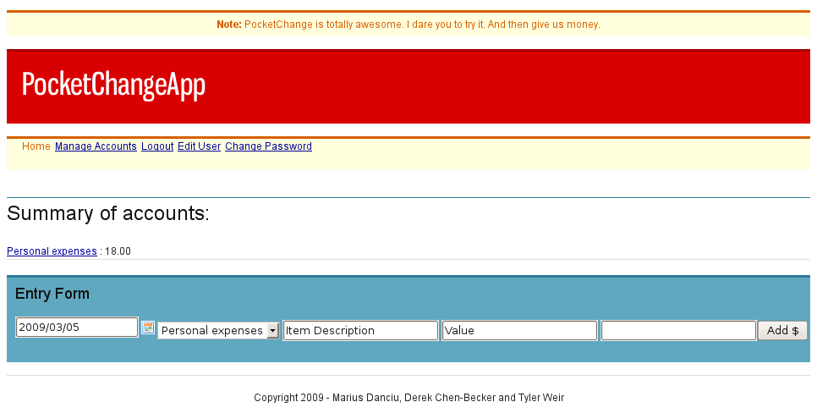

Figure 1-1. This is a figure caption. The style is Figure Caption.

Table 1-1. This Is a Table Caption. The Style is Table Caption.

|  |  |  |  |  |
| --- | --- | --- | --- | --- |
| Table Head | Table Head | Table Head | Table Head | Table Head |
| Table Text | -- | -- | Table Text | Table Text |
| -- | Table Text | -- | Table Text | Table Text |
| Table Text | Table Text | Table Text | Table Text | -- |
| Table Text | Table Text | Table Text | -- | Table Text |

Body Text. This is dummy text that is being repeated. This is dummy text that is being repeated. This is dummy text that is being repeated. This is dummy text that is being repeated.

This is a quote. This is dummy text that is being repeated. This is dummy text that is being repeated. This is dummy text that is being repeated. This is dummy text that is being repeated.

—Quote Source

**Results** This is dummy text that is being repeated. This is dummy text that is being repeated. This is dummy text that is being repeated. This is dummy text that is being repeated.

Body Text. This is dummy text that is being repeated. This is dummy text that is being repeated. This is dummy text that is being repeated. This is dummy text that is being repeated.

Exercise / Side Bar Head

Exercise Body. This is dummy text that is being repeated. This is dummy text that is being repeated. This is dummy text that is being repeated. This is dummy text that is being repeated.

* Exercise/SB Bullet: This is dummy text that is being repeated. This is dummy text that is being repeated. This is dummy text that is being repeated. This is dummy text that is being repeated.

Exercise Body. This is dummy text that is being repeated. This is dummy text that is being repeated. This is dummy text that is being repeated. This is dummy text that is being repeated.

1. Exercise/SB Num List: This is dummy text that is being repeated. This is dummy text that is being repeated. This is dummy text that is being repeated. This is dummy text that is being repeated.
2. Exercise/SB Num List: This is dummy text that is being repeated. This is dummy text that is being repeated. This is dummy text that is being repeated. This is dummy text that is being repeated.

Exercise Code

Nemo enim ipsam voluptatem quia voluptas

Nemo enim Code bold quia voluptas

sit aspernatur aut odit aut Nemo enim ipsam voluptatem quia voluptas

fugit, sed quia consequuntur magn

Nemo enim ipsam voluptatem quia voluptas

Exercise Code

Exercise Body. This is dummy text that is being repeated. This is dummy text that is being repeated. This is dummy text that is being repeated. This is dummy text that is being repeated.

Exercise Body Last. This is dummy text that is being repeated. This is dummy text that is being repeated. This is dummy text that is being repeated. This is dummy text that is being repeated.

Body Text. This is dummy text that is being repeated. This is dummy text that is being repeated. This is dummy text that is being repeated. This is dummy text that is being repeated.

## Symbols and Fonts

As you are writing your chapter, you may need to guide readers through steps or stages. To do that in the text, you use ä for this right-facing arrow: ä. It’s a ZapfDingbats font and you must it installed on your computer in order to properly view it. The Coordinating Editor can provide a font package to you for installation.

Here are examples of using the right-facing arrow:

To begin, launch Expression Blend and choose Help ä Welcome Screen.

To generate this document, choose File ä Export to Microsoft Word

You may also find that when you are writing code blocks, the code lines are too long to fit on one line of the page within this template. To show that a code line must continue, you use å for the code continuation character:

Here's an example of its use:

Public Sub New(ByVal n As String,ByVal a As Integer, ByVal i As Integer,ByValå

p As Single,ByVal s As String)

## Referencing Figures, Listings, and Tables

When you are inserting Figures, Listings, and Tables, you should not only follow the correct caption style, but also reference each of those Figures, Listings, and Tables within the preceding text. For example, for the first figure in Chapter 1, you would write something like: (see Figure 1-1), or as shown in Figure 1-1. For the second Listing in Chapter 2 you would write: (see Listing 2-2), or as shown in Listing 2-2. And for Table 3 in chapter 3, you would write: (see Table 3-3), or as in Table 3-3.

Also, it is important to note that these words (Figure, Listing, Table) are capitalized.

## Summary

Each chapter should have a summarizing paragraph. This concludes the section on examples of styles used in the template.

# Artwork

Two keys to ensuring readable images for print are consistency and contrast. It is important to create consistently sized and formatted art files; and whether it's line art, photos, or screenshots, each image's contrast must be effective. In order to optimize your book's images while not consuming too much of your time, we ask that you send the Coordinating Editor samples of your artwork right away. We will evaluate it and offer you feedback that you can employ when creating the rest of your project's artwork.

n **Note** While our e-formats utilize feature full-color imagery, our hard copy books are printed in grayscale. Always provide artwork in color, Apress will grayscale artwork for the print products.

In general, artwork should not be wider than the text width of any page. Place all your artwork in the Author Submission folder. Create separate zip files for each chapter's artwork. Each chapter should be named consistently and logically (i.e., ISBN\_Chapter\_01.zip would include Figure\_1-1.jpg, Figure\_1-2.jpg, etc.). Artwork should also be embedded in the Word template so that reviewers can see it. We realize that adhering to the following parameters won’t always be possible (particularly with screenshots), but the following are preferred file sizes, dimensions, and formats:

Size: Optimal (10 x 8 cm; 3.9 x 3.1 inches)

Resolution: 300dpi (preferred); 200dpi(minimum)

Formats: jpeg, png, tiff, eps, pdf (others are accepted)

Ideally, all artwork should be captured as large as possible so that it may be reduced or cropped preserving the resolutions. When it comes to screenshots, they should be captured as large as possible, but then cropped to the areas of concern. When the entire screenshot is necessary, the image can be left large as Production will reduce to trim size accordingly, preserving resolution.

A figure needs a figure caption using the Figure Caption style that goes below the figure. See [Referencing Figures, Listings, and Tables](#_Referencing_Figures,_Listings,) in this document for more detail.

In addition to figures, you may use illustrations. They are typically menu bars or buttons. Illustrations are introduced by the preceding text and must be placed exactly. If you want to describe several menu items, use illustrations. Illustrations are generally unnumbered in the text, but files should be named accordingly "Illustration\_1-1".

Here are a few examples.

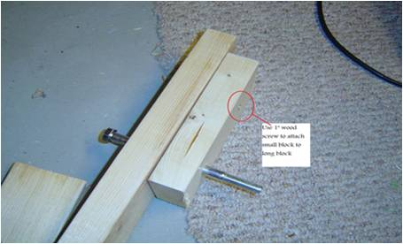

Figure 1.1. The raw sample

Figure 1.2. shows how it could have been more effectively cropped and saved.

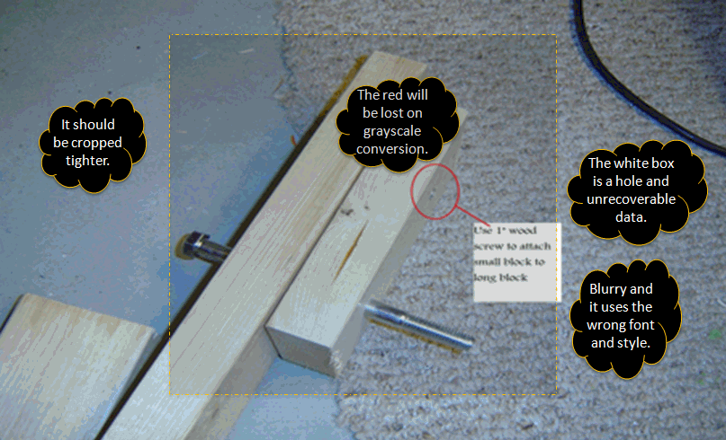

Figure 1.2. Marked-up sample

Based upon the marked up image, here is what an author should submit to SharePoint (Art Files > Author Submission) for actual use in the book, see Figure 1.3.

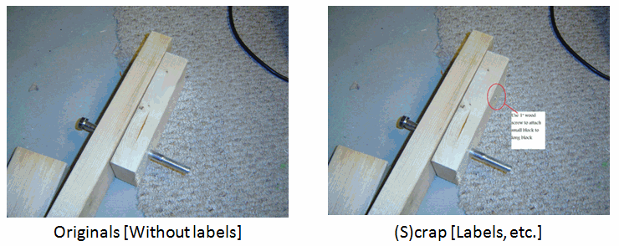

Figure 1.3. Clean photo without labels (left) and scrap photo with directional labels (right)

The scrap is for reference only and placed in the chapter file; the original file is the source image and placed in the Author Submission folder along with the scrap for reference.

All line artwork will be redrawn by our artists. This is done for consistency and to align them with our grayscale printing specs.

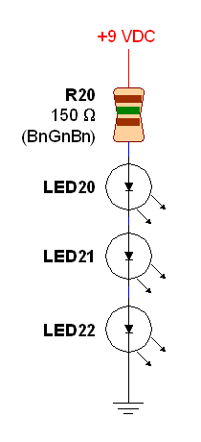 C:\Documents and Settings\frankm\My Documents\Apress\Presentations\Port_Presentation\Art Samples\Art Samples\Bad art\27489f2226v1.eps

Figure 1.4. Color artwork redrawn and grayscaled. All eps files look jagged in the Word file but reproduce perfectly in print.

Keep artwork elements organized and easily accessible on SharePoint:

* Separate artwork by chapter
* Zip all chapter folders along with re-submissions
* Individual files should be named 9781430212345\_Figure\_01-01.jpg and the chapter folders named 9781430212345\_Chapter\_01.zip
* Post all zip files to SharePoint > Art Files > Author Submission

## Callouts and Cropping

Callouts are annotations on a figure. They need to be consistent throughout the book. If you want callouts, create the screenshot and supply the original along with a screenshot that includes your notations. Place marked up or "scrap" versions in the chapter document and be sure both images are supplied in the Author Submission area.

Cropping allows you to focus on a part of the screenshot. Most of the time these are menu items. We suggest you crop all images within the chapter. Like callouts, you should crop all images within the Word file and provide the uncropped in the submission folder. This will allow us to size the art efficiently.

## Screenshots

Screenshots are usually shot between 72 and 150 dpi due to screen resolution. Most formats are acceptable like .tif, .jpg., and .png. We suggest that you use SnagIt, though there are many acceptable programs. Your Coordinating Editor can give you access to the SnagIt program if necessary. When using color, please use high contrast and avoid dark screens. If possible, convert a sample to grayscale to see if your screenshots will be distinguished properly. In the end, always provide artwork in full color when possible.

## Line Art

All line art is re-drawn and re-labeled. While eps files are preferred when creating line art, others are accepted like pdfs, jpegs, tiffs, and .png files as well as other formats. If there is room for us to misinterpret the art, please put notes on it so that we know what you want. Art is a source of errors in books, so the better we start, the better chance we have in getting exactly what we need.

## Photographs

The best photographs have good contrast and as much light as possible. We prefer photos at 300 dpi when possible. Less than 300 dpi will increase the potential for a poor print product. We accept all files like .tif, .jpg, and .png. All photos should be in color and thumbnails of any kind will generally not work.

## Summary

If you have any questions or concerns along the way, let your Coordinating Editor know. The key to writing a professional title is to be consistent in styles, text, and art. This will make the reader experience a pleasurable one. We know your book’s going to read well–we want to make sure it looks fantastic, as well.

n **Note** This page could be intentionally left blank, because every chapter should end on an EVEN numbered page, even if a blank needs to be added at the end.